**A**

***PROJECT REPORT***

*On*

**Tour and Travels Website**

*Submitted in partial fulfilment of the requirements for the degree of*

**BACHELOR OF TECHNOLOGY**



Session: - 2024

Submitted by

Yogesh Sankhla (20ETCSS121)

Parv Jain (20ETCCS084)

8th Sem (CSE)

Under Guidance of

Mr. Aaditya Maheshwari

Assistant Professor

Dept. of CSE TINJRIT, Udaipur

**DEPARTMENT OF COMPUTER SCIENCE AND ENGINEERING**

**TECHNO INDIA NJR INSTITUTE OF TECHNOLOGY, UDAIPUR-313001**

**2024**



Department of Computer Science and Engineering

Techno India NJR Institute of Technology, Udaipur-313001

**Certificate**

This is to certify that project work titled **Tour and Travels Website** by **Yogesh Sankhla** was successfully carried out in the Department of Computer Science and Engineering, TINJRIT and the report is approved for submission in the partial fulfillment of the requirements for award of degree of Bachelor of Technology in Computer Science and Engineering.

Mr. Aaditya Maheshwari Dr. Rimpy Bishnoi

Assistant Professor Head of Department

Dept. of CSE TINJRIT, Udaipur Dept. of CSE TINJRIT, Udaipur

Date Date



Department of Computer Science and Engineering

Techno India NJR Institute of Technology, Udaipur-313001

**Certificate**

This is to certify that project work titled **Tour and Travels Website** by **Parv Jain** was successfully carried out in the Department of Computer Science and Engineering, TINJRIT and the report is approved for submission in the partial fulfillment of the requirements for award of degree of Bachelor of Technology in Computer Science and Engineering.

Mr. Aaditya Maheshwari Dr. Rimpy Bishnoi

Assistant Professor Head of Department

Dept. of CSE TINJRIT, Udaipur Dept. of CSE TINJRIT, Udaipur

Date Date

**Examiner Certificate**

This is to certify that the following students **Yogesh Sankhla** of final year B.Tech. (Computer Science and Engineering), was examined for the project work titled

***Tour and Travels Website*** during the academic year 2023 – 2024 at Techno India NJR Institute of Technology, Udaipur.

**Remarks:**

**Date:**

Signature Signature

(**Internal Examiner**) (**External Examiner**)

Name :- Name :-

Designation:- Designation:-

Department: - Department: -

Organization:- Organization:-

**Examiner Certificate**

This is to certify that the following students **Parv Jain** of final year B.Tech. (Computer Science and Engineering), was examined for the project work titled

***Tour and Travels Website*** during the academic year 2023 – 2024 at Techno India NJR Institute of Technology, Udaipur.

**Remarks:**

**Date:**

Signature Signature

(**Internal Examiner**) (**External Examiner**)

Name :- Name :-

Designation:- Designation:-

Department: - Department: -

Organization:- Organization:-

**ACKNOWLEDGMENT**

We take this opportunity to record our sincere thanks to all who helped us to successfully complete this work. Firstly, We are grateful to our **supervisor Mr. Aaditya Maheshwari** for his invaluable guidance and constant encouragement, support and most importantly for giving us the opportunity to carry out this work.

We would like to express our deepest sense of gratitude and humble regards to our

**Head of Department Dr. Rimpy Bishnoi** for giving invariable encouragement in our endeavors and providing necessary facilities for the same. Also a sincere thanks to all faculty members of CSE, TINJRIT for their help in the project directly or indirectly.

Finally, We would like to thank my friends for their support and discussions that have proved very valuable for us. We are indebted to our parents for providing constant support, love and encouragement. We thank them for the sacrifices they made so that we could grow up in a learning environment. They have always stood by us in everything we have done, providing constant support, encouragement and love.

**Yogesh Sankhla (20ETCCS121)**

**Parv Jain (20ETCCS084)**

DEPARTMENT OF COMPUTER SCIENCE AND ENGINEERING

TECHNO INDIA NJR INSTITUTE OF TECHNOLOGY, UDAIPUR-313001

**CONTENTS**

|  |  |
| --- | --- |
| **Name of Contents** | **Page No.** |
| Certificate 1 |  |
| Certificate 2 |  |
| Acknowledgements |  |
| List of Tables |  |
| List of Figures |  |
| Chapter 1: Introduction   * 1. Title of Project   2. Introduction   3. Objective of the Project   4. Scope of the Project   5. Methodology   6. Software/ Technology Used |  |
| Chapter 2:Frontend of Project  2.1 Introduction  2.2 Interactive User interface |  |
| Chapter 3: Using React.js  3.1 Pages  3.2 Components |  |
| Conclusion |  |
| Future Scope |  |
| Bibliography |  |

**LIST OF FIGURES**

|  |  |
| --- | --- |
| FIG.1: React.js Architecture |  |
| FIG.1.2: API Fetching in React.js |  |
| FIG 2.1: TourSense Home Page |  |
| FIG.2.2: About Us Page |  |
| FIG.2.3**:** Our Services Page |  |
| FIG 2.4: Contact Us Page |  |
| FIG.3.1: Index.html |  |
| FIG.3.2:Index.css |  |
| FIG.3.3: Index.js |  |
| FIG.3.4: Service.js |  |
| FIG. 3.5: Home.js |  |
| FIG.3.6: Contact.js |  |
| FIG.3.2.1: Destination.js |  |
| FIG.3.2.2: Destination Data.js |  |
| FIG. 3.2.3: Footer.js |  |
| FIG.3.2.4: navbar.js |  |

**CHAPTER 1: INTRODUCTION**

**Name of the project:**

Tour and Travels Website

**Problem Statement:**

The absence of a user-friendly and responsive tour and travel website built on React.js hinders the tourism industry from providing a modern, interactive, and efficient platform for users to explore, plan, and book their travel experiences.

**Objective of the project:**

To develop a cutting-edge tour and travel website using React.js, with the aim of enhancing user experience, simplifying the travel planning process, and providing tour operators a robust platform for efficient management and promotion of their services, ultimately revolutionizing the tourism industry's online presence.

**Scope of the project:**

1. **Dynamic Content Rendering:** Utilize React's component-based architecture to create reusable components for displaying dynamic content such as destination cards, travel packages, and reviews.
2. **State Management:** Manage application state efficiently using React's state management features or libraries like Redux or Context API. This allows for dynamic updates based on user interactions, such as filtering destinations or updating booking information.
3. **Routing**: Implement client-side routing with React Router to create a seamless navigation experience between different pages of your website, such as home, destinations, packages, and blog.
4. **API Integration:** Fetch data from external APIs to populate your website with real-time information about destinations, accommodations, flights, and activities. This could include APIs for weather forecasts, flight bookings, hotel reservations, and tourist attractions.
5. **User Interaction:** Enhance user interaction with features like interactive maps, image sliders, and modal pop-ups to provide a visually engaging experience for users exploring destinations and travel packages.
6. **Form Handling:** Implement forms for user input, such as search filters, booking inquiries, and contact forms, using controlled components in React. You can validate user input and provide feedback in real-time to improve the user experience.
7. **Responsive Design:** Design your website to be fully responsive across various devices and screen sizes using responsive CSS frameworks like Bootstrap or Material-UI. This ensures that users can access your website seamlessly from desktops, tablets, and smartphones.

**Methodology:**

1. **Define Requirements:** Begin by clearly defining the requirements and objectives of your tour and travel website. Understand your target audience, the type of travel experiences you want to offer, and the key features your website should have.
2. **Wireframing and Design:** Create wireframes and design mockups of your website's user interface (UI) using tools like Sketch, Figma, or Adobe XD. Focus on creating intuitive navigation, visually appealing layouts, and engaging content presentation.
3. **Component Breakdown:** Identify the different components needed for your website, such as header, footer, navigation bar, destination cards, search filters, booking forms, and interactive maps. Break down the UI design into reusable React components.
4. **Set Up Project Structure**: Initialize a new React project using Create React App or another boilerplate tool. Organize your project structure with directories for components, styles, assets, and any additional resources.
5. **Implement UI Components:** Begin implementing UI components based on your design mockups. Use JSX syntax to define the structure and logic of each component, and style them using CSS or a CSS-in-JS solution like styled-components or Emotion.

**Software/ Technology used:**

* React JS 18.2.0
* Javascript ES14
* GitHub

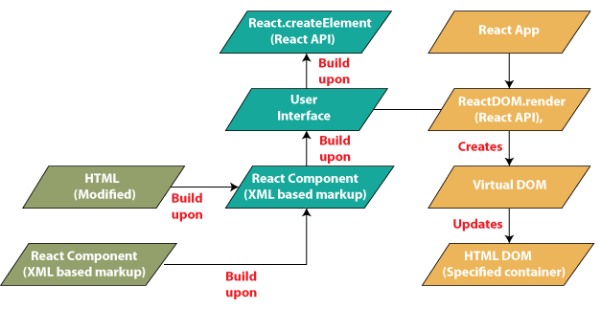

**Fig.1.1 React.js Architecture**

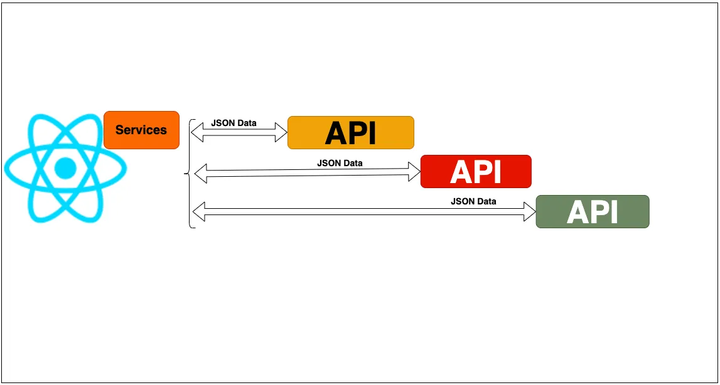

**Fig.1.2 API Fetching in React.js**

**Chapter 2: Frontend of Project**

**2.1 Introduction:-**

Toursense is a dynamic and user-centric tour and travel website designed to inspire wanderlust and facilitate seamless travel experiences. Leveraging the power of React.js, our platform offers an intuitive interface, rich user interactions, and real-time updates, ensuring an immersive and personalized journey for every user**.**

* **Interactive Destination Explorer:** Delve into a world of possibilities with our interactive destination explorer. From sun-kissed beaches to majestic mountains, users can browse through a curated collection of destinations, each accompanied by captivating imagery and insightful descriptions.
* **Tailored Travel Packages:** Discover the perfect itinerary for your next adventure with our meticulously crafted travel packages. Whether it's a romantic getaway, a family vacation, or an adrenaline-fueled expedition, our platform offers a diverse range of customizable packages to suit every traveler's preferences and budget.
* **Seamless Booking Experience:** Streamline the booking process with our seamless and intuitive booking interface. With real-time availability updates, secure payment options, and instant confirmation, users can book their dream vacations with confidence and ease.
* **Engaging Content Hub:** Immerse yourself in a world of travel inspiration with our engaging content hub. From travel guides and insider tips to captivating stories and breathtaking photography, our platform offers a treasure trove of resources to fuel your wanderlust and enhance your travel experience.
* **User-Friendly Interface:** Personalize your travel experience with our user friendly dashboard. Keep track of your bookings, manage your preferences, and access exclusive deals and discounts, all from onecentralized location.

**2.2 Interactive User Interface**

**Fig 2.1: TourSense Home Page**

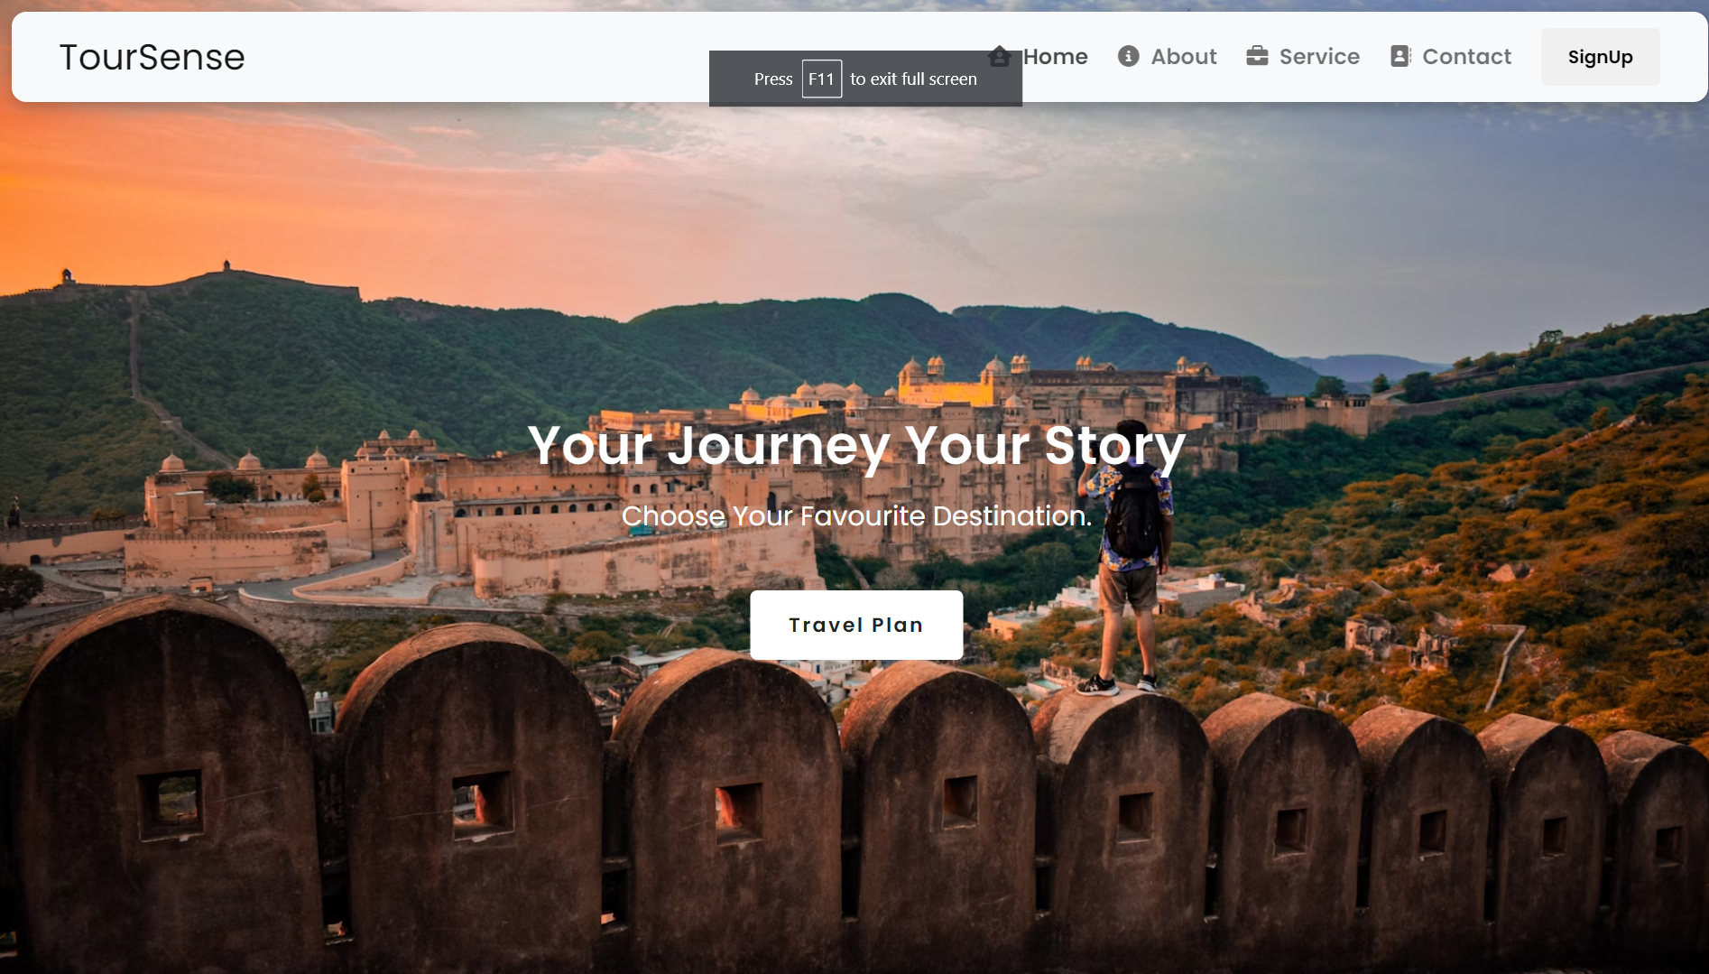

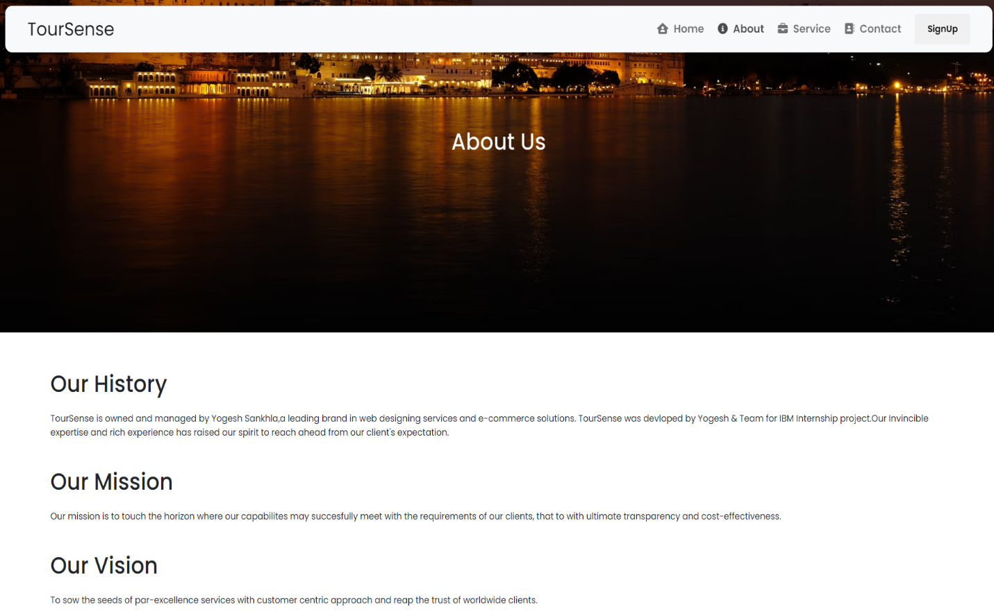

**Fig 2.2: About Us Page**

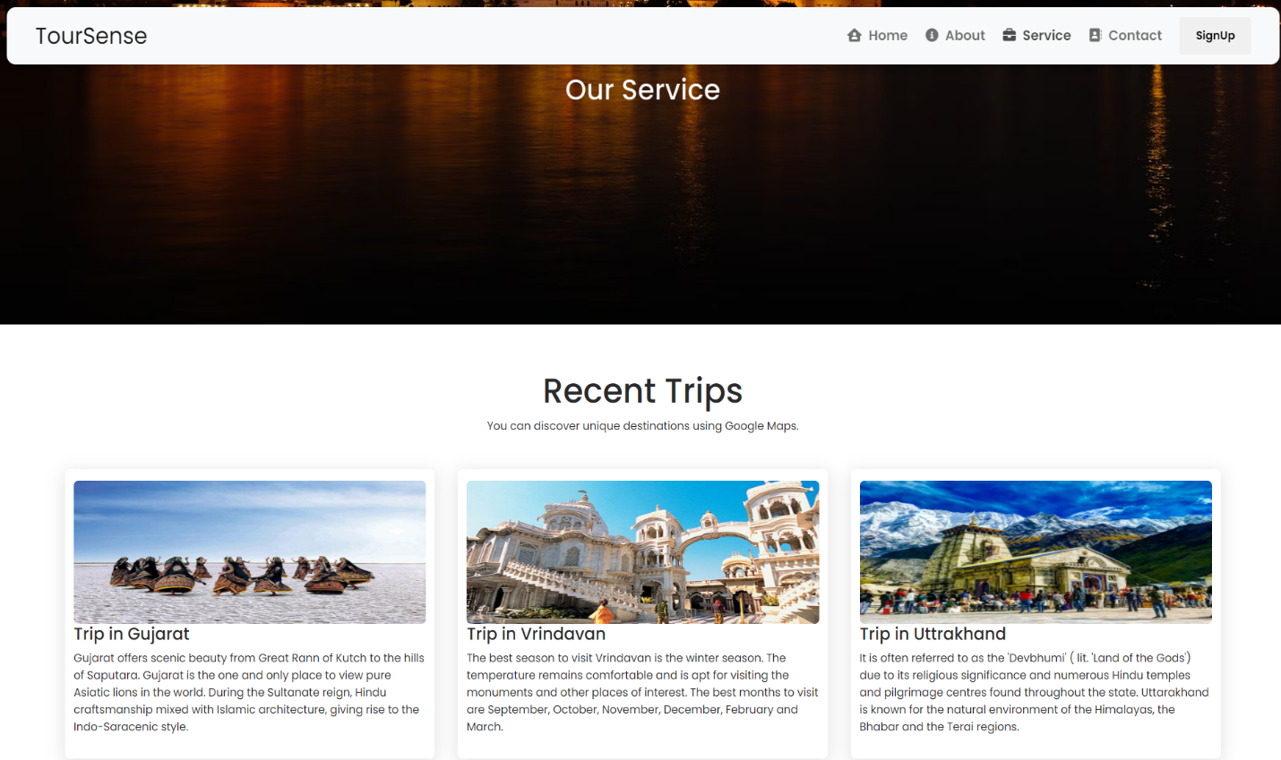

**Fig 2.3: Our Services Page**

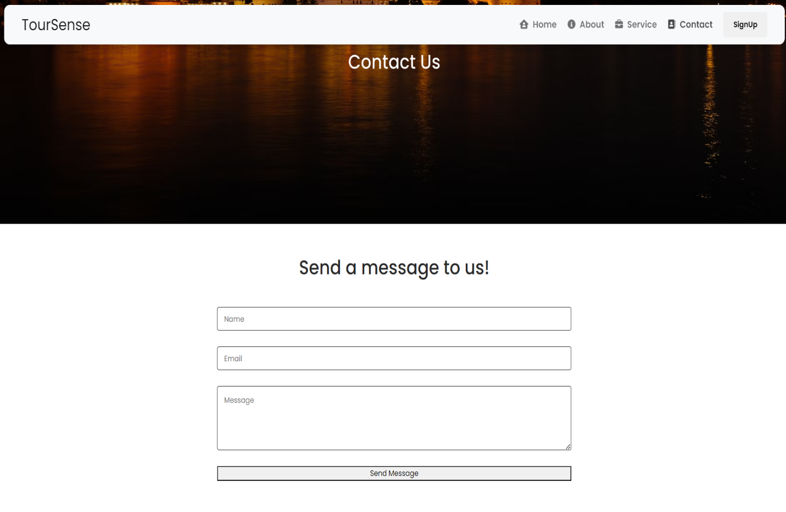

**Fig 2.4: Contact Us Page**

**CHAPTER 3 : Using React.js**

React.js, commonly referred to as React, is an open-source JavaScript library maintained by Facebook and a community of developers. It's primarily used for building user interfaces (UIs) and single-page applications (SPAs). Here's a brief description of React.js:

**Component-Based Architecture:** React follows a component-based architecture where UIs are composed of independent and reusable components. Each component encapsulates its own logic, state, and rendering behavior, allowing developers to build complex UIs more efficiently.

**Virtual DOM:** React utilizes a virtual DOM (Document Object Model) to optimize UI updates. Instead of directly manipulating the browser's DOM, React creates a lightweight virtual representation of the DOM and updates it efficiently. This approach improves performance by minimizing unnecessary re-renders and efficiently updating only the parts of the DOM that have changed.

**JSX (JavaScript XML):** JSX is a syntax extension for JavaScript that allows developers to write HTML-like code within JavaScript. It enables the seamless integration of UI components and logic within React components, making the code more readable and expressive.

**Declarative Syntax:** React promotes a declarative programming style, where developers describe the desired UI state and let React handle the underlying DOM updates. This simplifies the development process and improves code maintainability.

**Unidirectional Data Flow:** React follows a unidirectional data flow, where data flows from parent components to child components through props. This helps maintain data consistency and predictability within the application, making it easier to debug and reason about.

**React Hooks:** Introduced in React 16.8, React Hooks are functions that enable developers to use state and other React features in functional components. Hooks provide a simpler and more flexible way to manage component state and lifecycle methods, eliminating the need for class components in many cases.

**3.1 Pages :**

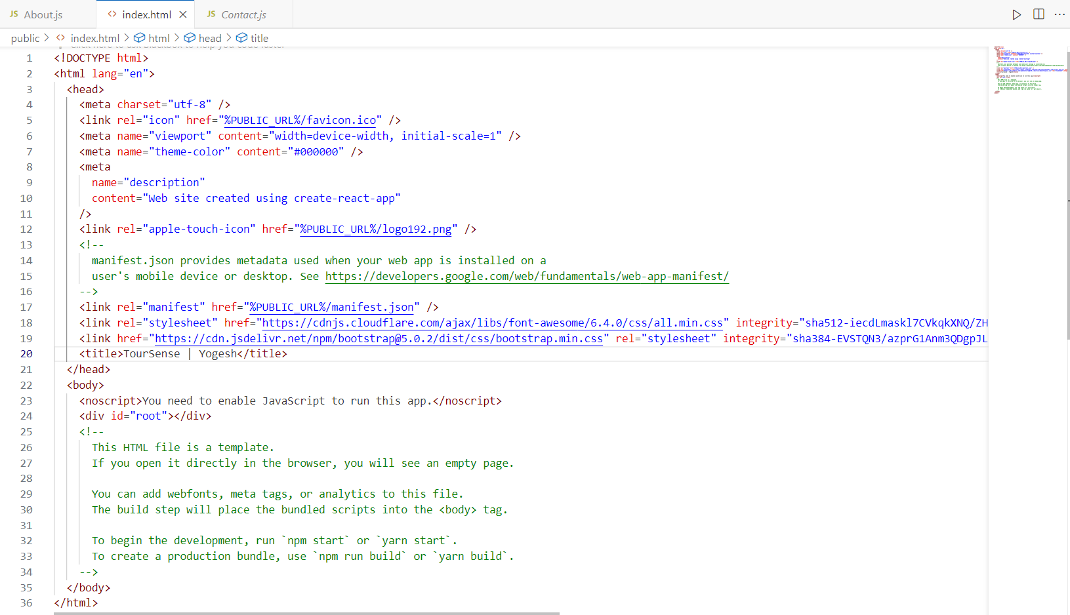

**Fig 3.1: Index.html**

**Fig 3.2: 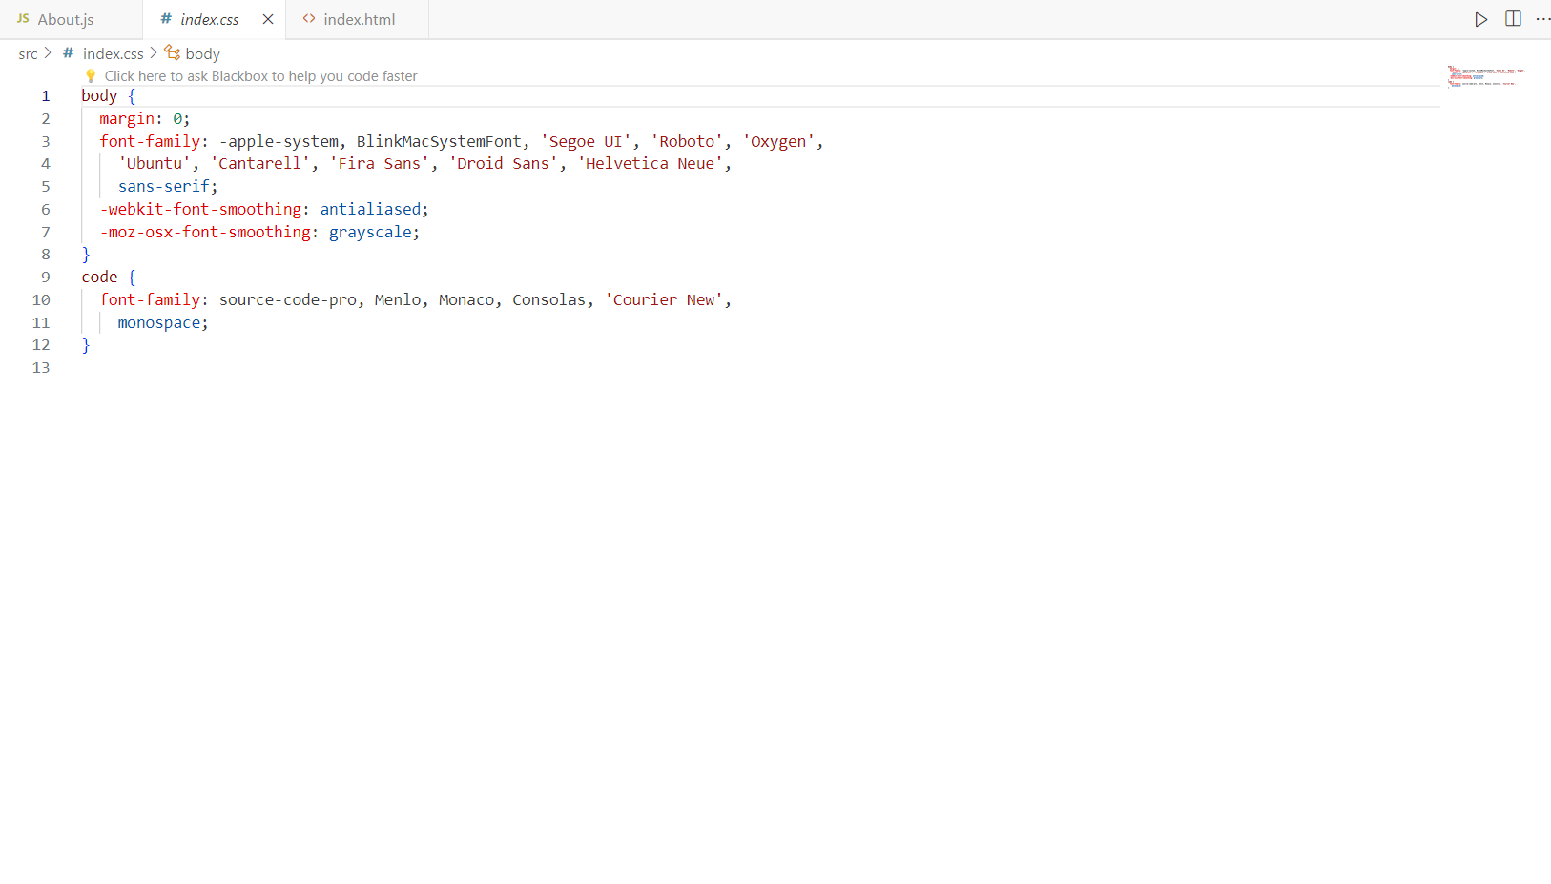Index.css**

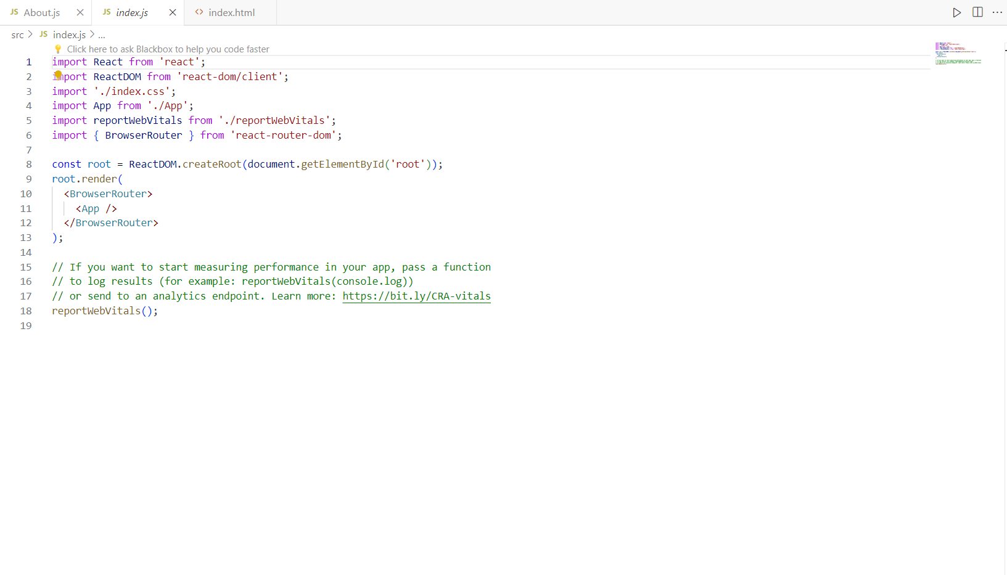

**Fig 3.3: Index.js**

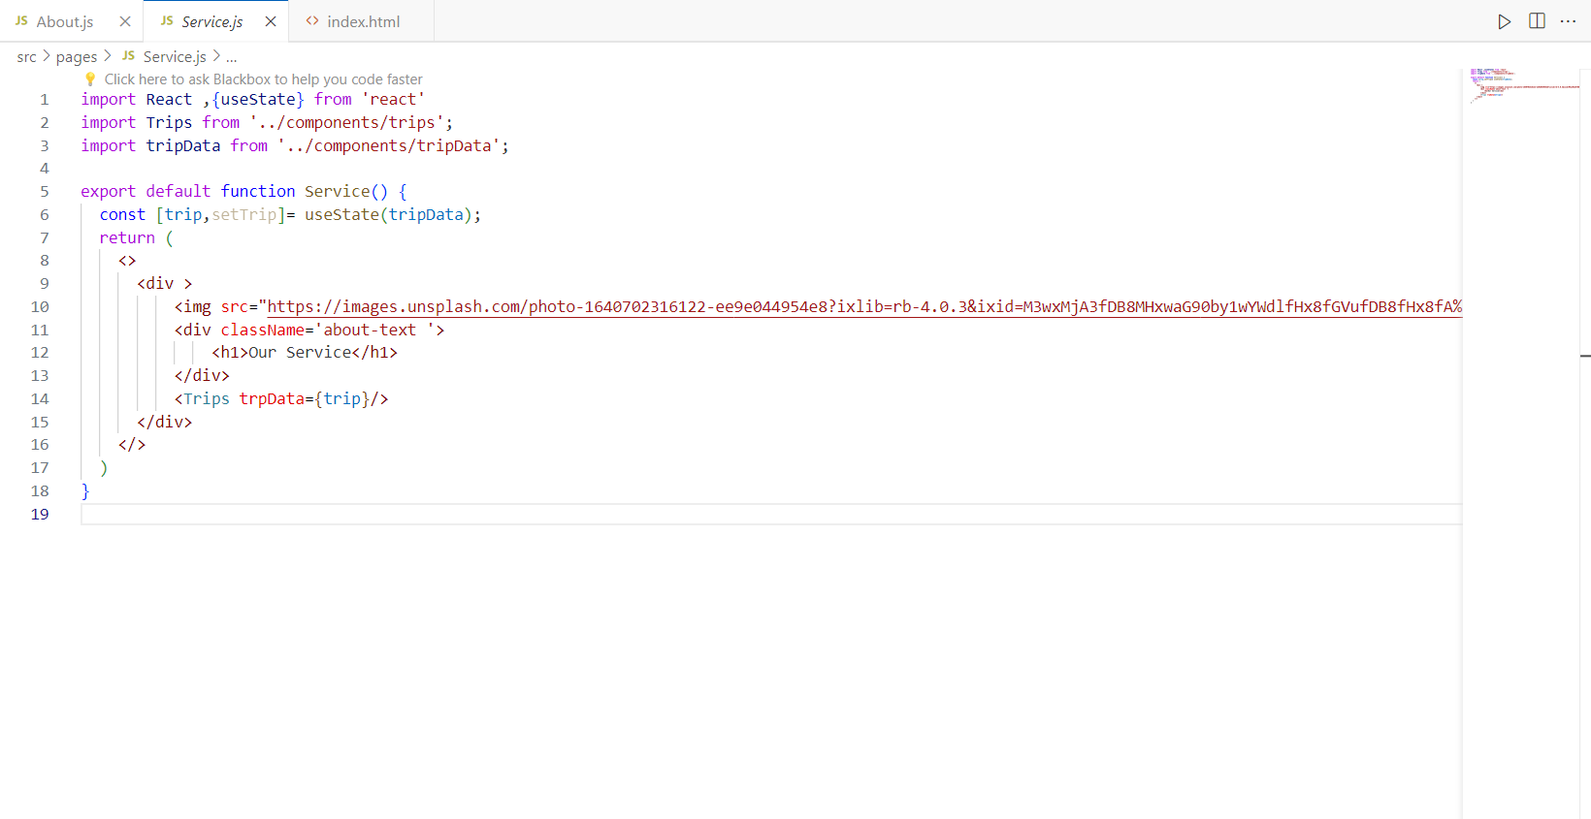

**Fig 3.4: Service.js**

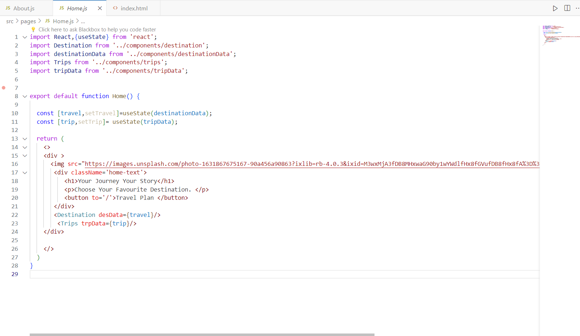

**Fig 3.5: Home.js**

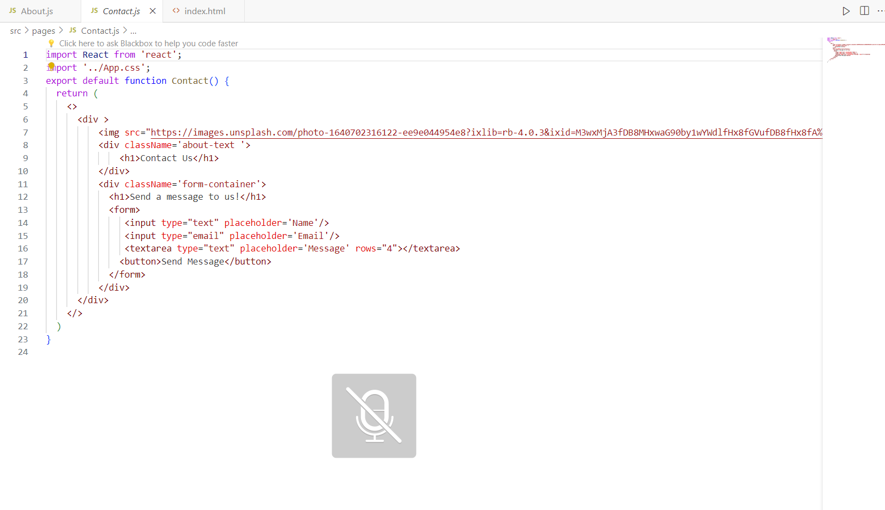

**Fig 3.6: Contact.js**

**3.2 Components :**

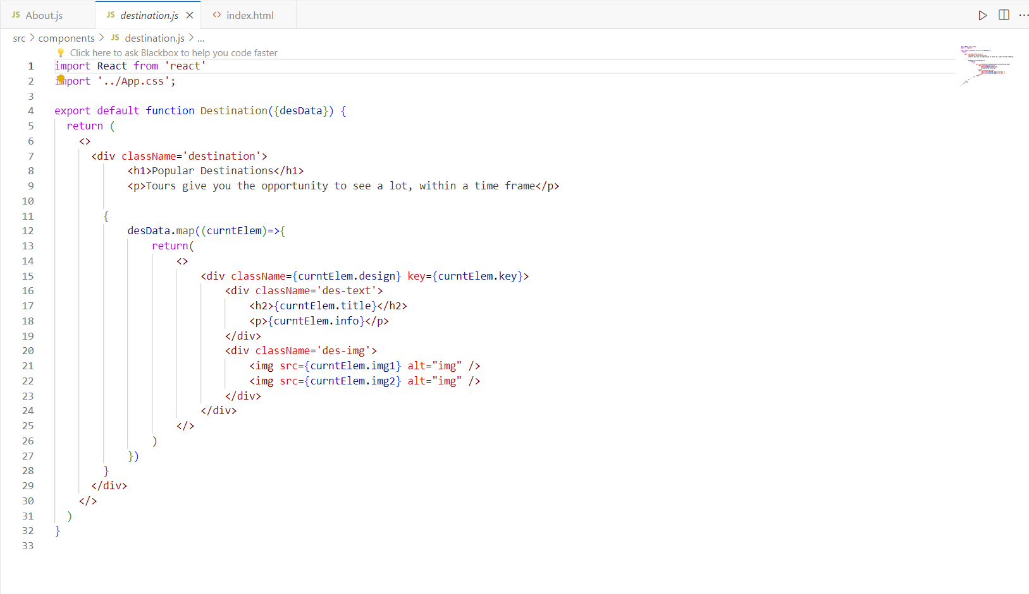

**Fig 3.2.1: Destination.js**

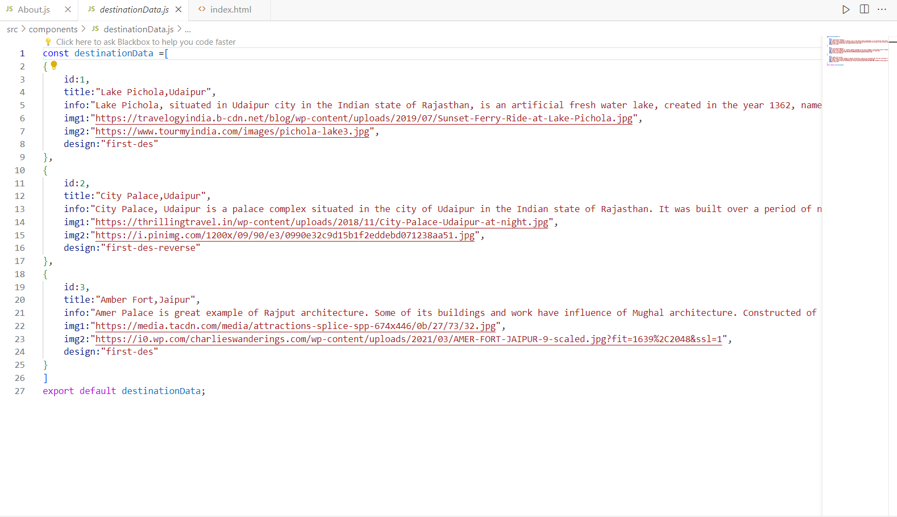

**Fig 3.2.2: Destination Data.js**

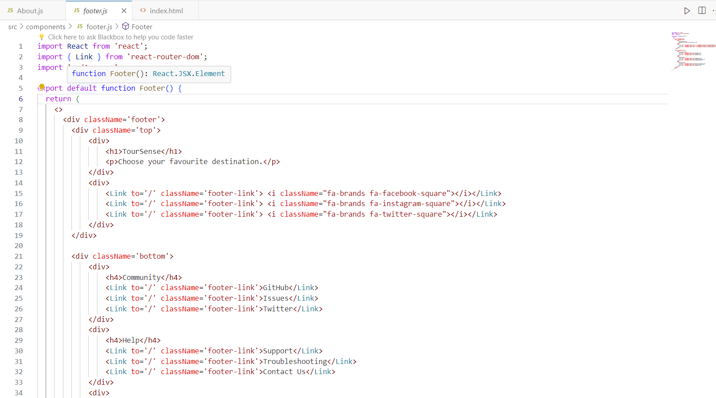

**Fig 3.2.3: Footer.js**

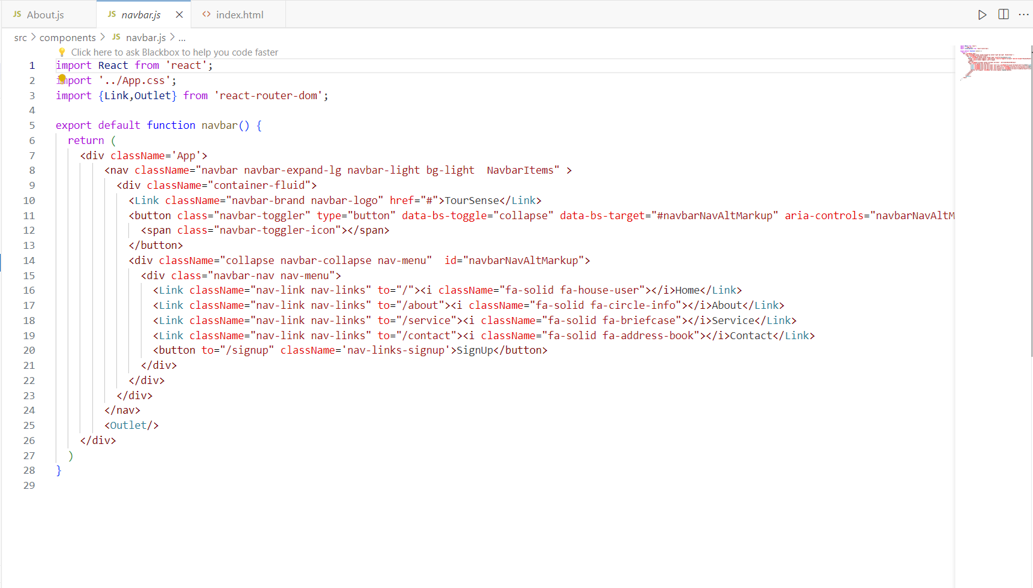

**Fig 3.2.4: navbar.js**

**Conclusion:**

In conclusion, the development of a tour and travels website using React.js offers a myriad of benefits for both developers and end-users alike. By harnessing the power of React.js, we have created a dynamic and responsive platform that seamlessly integrates user interaction with captivating visual elements.

Through the utilization of React components, we have ensured modularity and reusability, facilitating easier maintenance and scalability of the website. The virtual DOM manipulation provided by React.js contributes to faster rendering, enhancing the overall performance and user experience.

Moreover, the incorporation of state management libraries like Redux ensures efficient data flow and synchronization, enabling seamless communication between different components of the website.

With its declarative syntax and component-based architecture, React.js empowers developers to build highly interactive and engaging user interfaces, thereby enriching the browsing experience for travelers and adventure enthusiasts.

In essence, the adoption of React.js has allowed us to create a tour and travels website that not only meets the functional requirements but also exceeds expectations in terms of performance, scalability, and user satisfaction. As we continue to evolve and enhance the platform, we remain committed to delivering exceptional value and unforgettable experiences to our users in their journey of exploration and discovery.

**Future Scope:**

Looking ahead, the future scope of a tour and travels website built with React.js is promising, offering opportunities for further innovation and enhancement. Here are some potential avenues for future development:

**Personalized User Experience:** Implementing machine learning algorithms or advanced analytics to analyze user behavior and preferences can enable the website to offer personalized recommendations for destinations, activities, and travel packages. This customization can greatly enhance user satisfaction and increase conversion rates.

**Integration of Virtual Reality (VR) and Augmented Reality (AR):** Incorporating VR and AR technologies into the website can provide immersive experiences for users, allowing them to virtually explore destinations, hotels, and attractions before making a booking decision. This futuristic approach can set the website apart and attract tech-savvy travelers.

**Enhanced Mobile Experience:** As mobile usage continues to rise, optimizing the website for mobile devices and implementing progressive web app (PWA) features can ensure a seamless and intuitive experience for users on smartphones and tablets. This includes features like offline access, push notifications, and faster loading times.

**Social Media Integration**: Integrating social media features such as user reviews, social sharing, and social login can foster community engagement and word-of-mouth marketing. Additionally, leveraging social media APIs for travel inspiration, user-generated content, and influencer partnerships can broaden the website's reach and appeal.

**Accessibility and Inclusivity:** Ensuring that the website adheres to web accessibility standards (WCAG) and is inclusive to users with disabilities can expand the audience reach and demonstrate a commitment to diversity and inclusivity. This involves optimizing UI elements, providing alternative text for images, and implementing keyboard navigation.

**Expansion into New Markets:** Exploring opportunities to expand the website's offerings into new markets or niche segments, such as eco-tourism, adventure travel, or sustainable travel, can attract a diverse range of travelers and tap into emerging trends.

**Dynamic Pricing and Revenue Management**: Implementing dynamic pricing algorithms and revenue management strategies can optimize pricing strategies based on demand fluctuations, seasonality, and competitor analysis. This can maximize revenue generation while ensuring competitive pricing for customers.

**Integration with Emerging Technologies:** Keeping abreast of emerging technologies such as blockchain for secure transactions, voice search for hands-free navigation, and chatbots for customer support can enhance the website's functionality and provide innovative solutions to user needs.

By embracing these future opportunities and continuously iterating on the website's features and functionalities, a tour and travels website built with React.js can stay ahead of the curve and remain competitive in the ever-evolving travel industry.

**Bibliography:**

* **React Documentation:-**

[**https://legacy.reactjs.org/docs/getting-started.html**](https://legacy.reactjs.org/docs/getting-started.html)

* **Github:-**

[**https://github.com/YogeshYL/tour-Travel**](https://github.com/YogeshYL/tour-Travel)